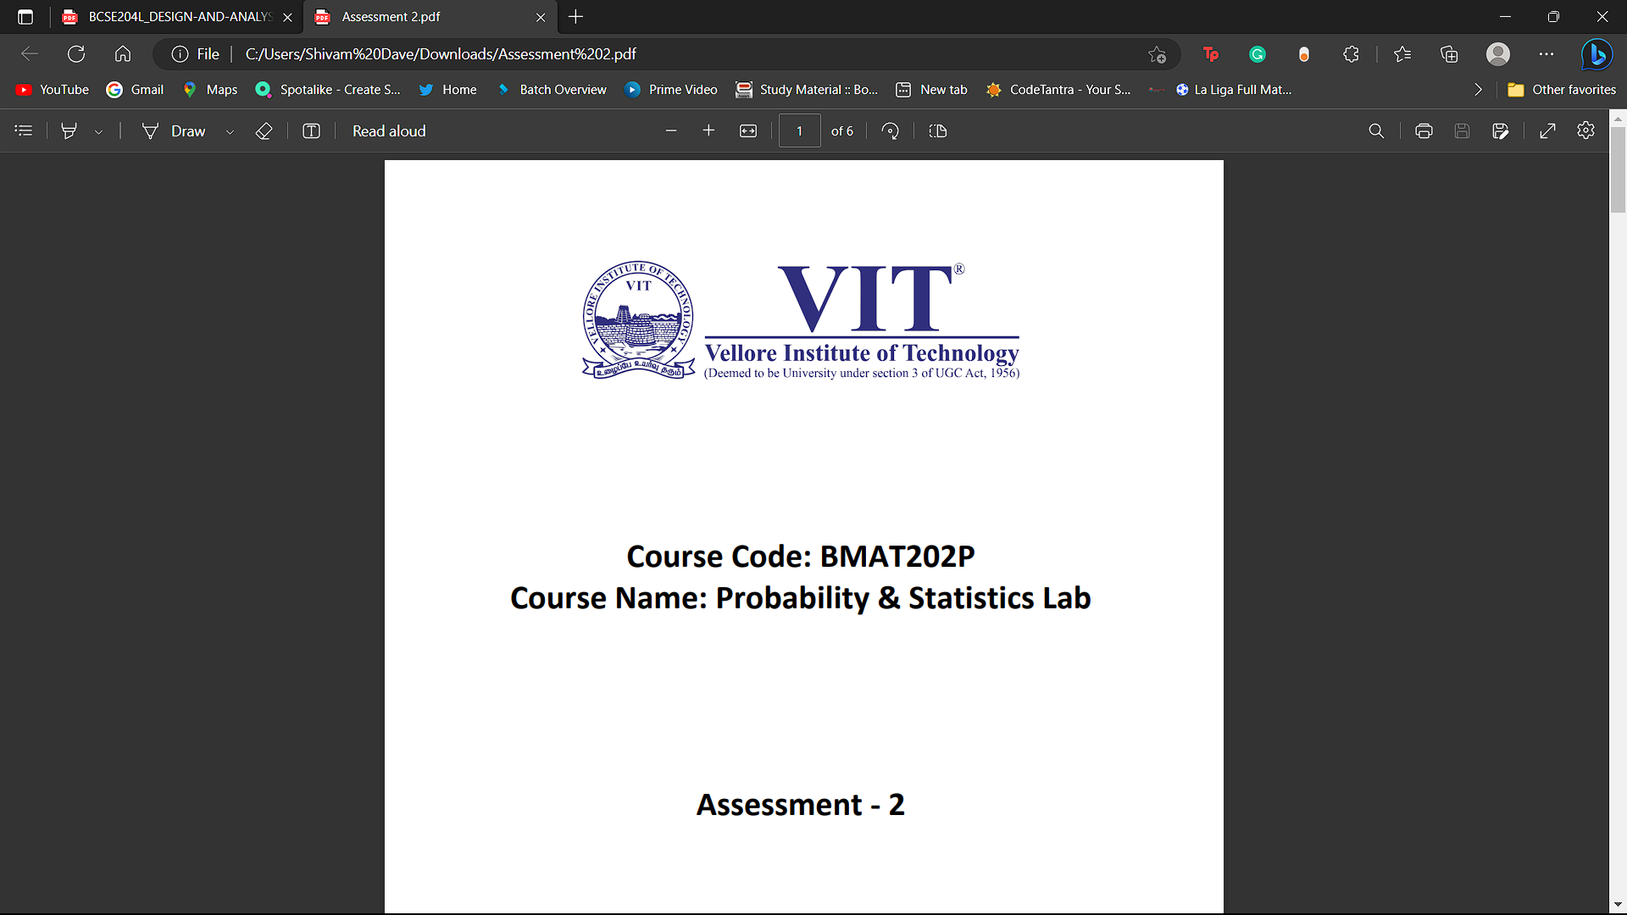

**Name:** Shivam Dave

**Regno:** 21BCB0107

**Slot:** L21+L22

**Date:** 1.06.2023

**Question:**

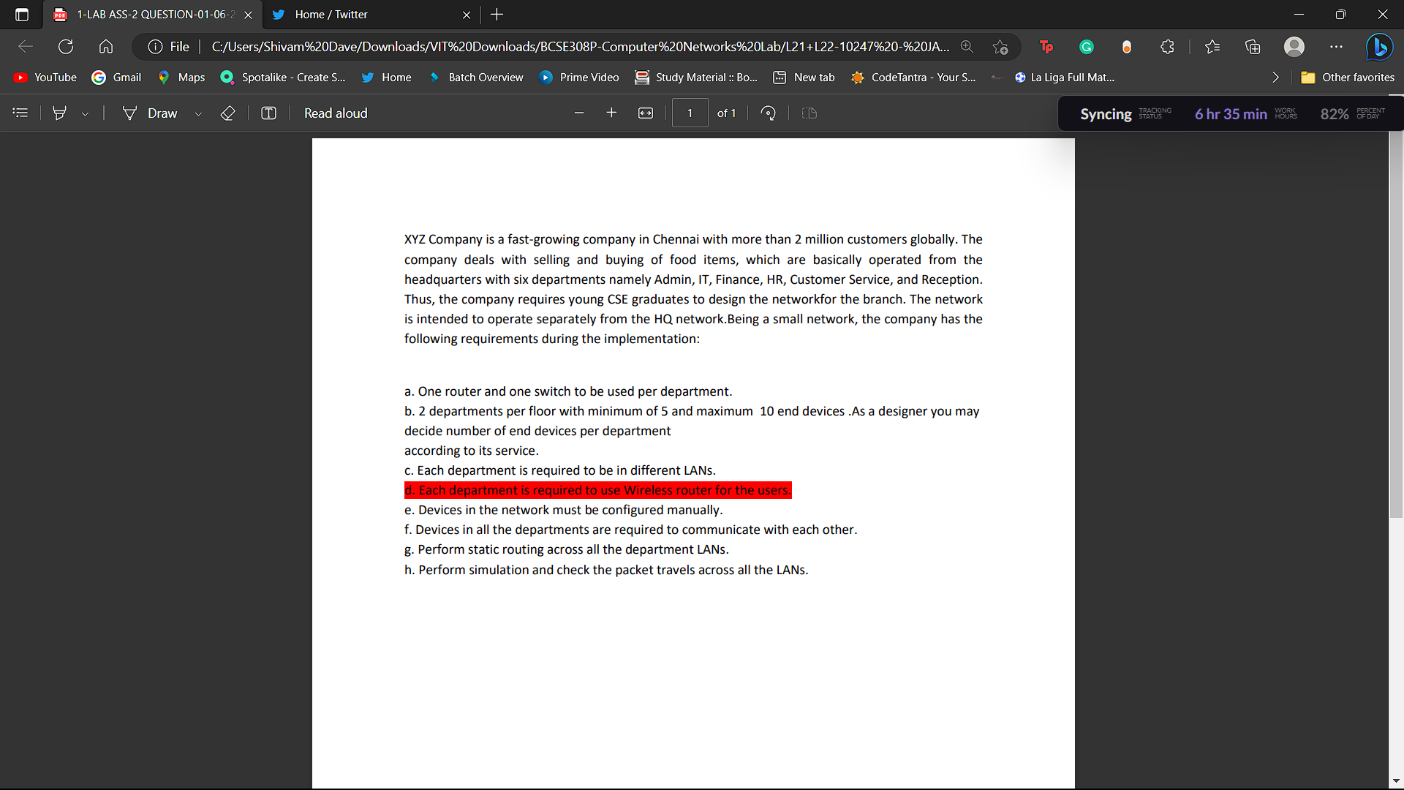

**Solution:**

**Configuration for systems(pc) for each LAN network(HR, finance,etc)**

* Select end devices and drag them(atleast 5 each for each LAN)
* Select switches(2960/PT) and drag them
* Using wire connect them with eachother as shown.

**Screenshot:**

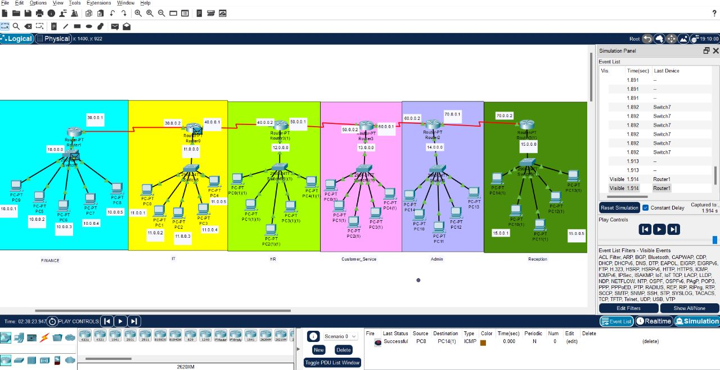

**Follow the same steps for other Networks.**

**Step 2:**

**IP configurations for PCs/End devices**

* The end devices have Ip4 configuration and the LANs IP address can be the default gateway (x.x.x.0)

**Step 3:**

**Ip configurations for routers:**

* Drag routers and place them accordingly(One for each Network).
* Each router will have atleast 2 connections. One for the switch connecting the end devices and one connecting one router with another.
* The connection of router from router can be made using SERIAL DCE and the IP connection/Default Gateway.
* The connection of router with the switch will have the IP address of the LAN.

**Screenshot:**



**Step 4: Router to router connection**

First we will assign each router the Default Gateway for each LAN network from interface of FastEthernet()

Screenshot:

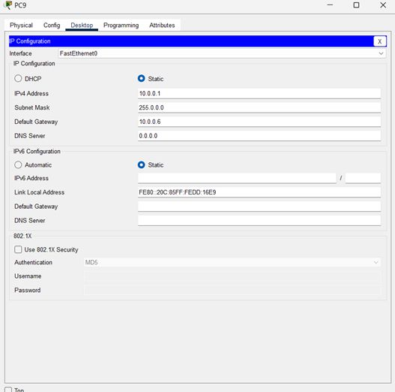

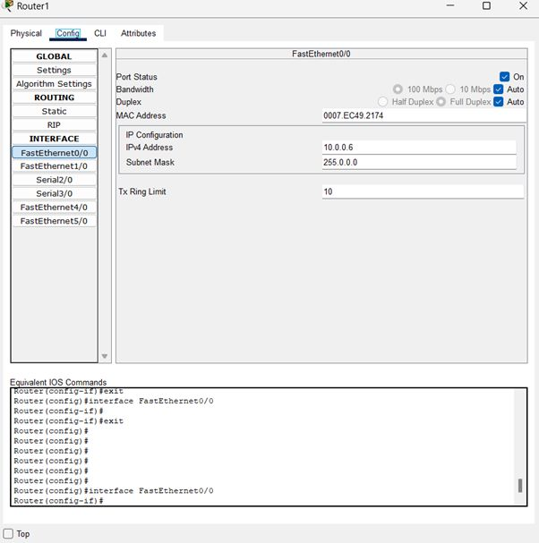

Next, router to router configuration involves the routing table which contains the IP address of all the destination routers and Next Hop IP.

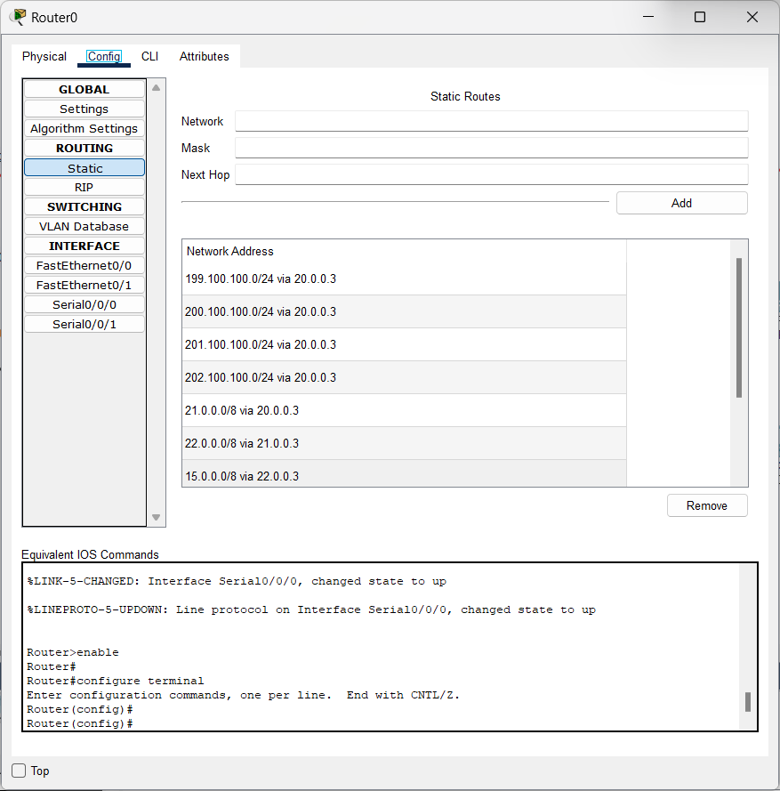

**Step 5: We will Simulate and get the output:**



